**FPT POLYTECHNIC – TAY NGUYEN**

---o0o---

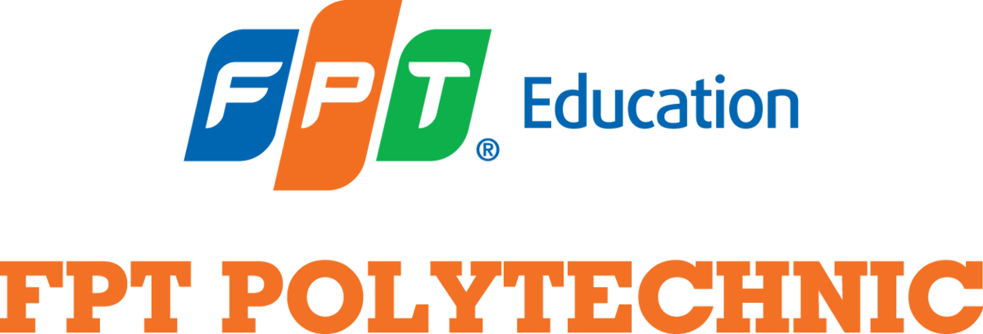

**ASSIGNMENT**

**ENGLISH 1.1**

**Full name: Vi Van Tuan**

**Student code: PK02312  
 Class: ENT1127.01**

**Lecturer: Võ Thị Cẩm Diệu**

***BMT, June, 2023***

**TABLE OF CONTENTS**

TOPIC 1: MY FRIEND 3

TOPIC 2: MY MUSICAL TASTE 4

TOPIC 3: MY FAMILY 5

TOPIC 4: MY FAVORITE RESTAURANT 6

# TOPIC 1: TALK ABOUT A HOTEL THAT YOU HAVE STAYED IN

Hello Hello everyone, my name is Tuan. Today I will introduce the hotel that I have stayed in.

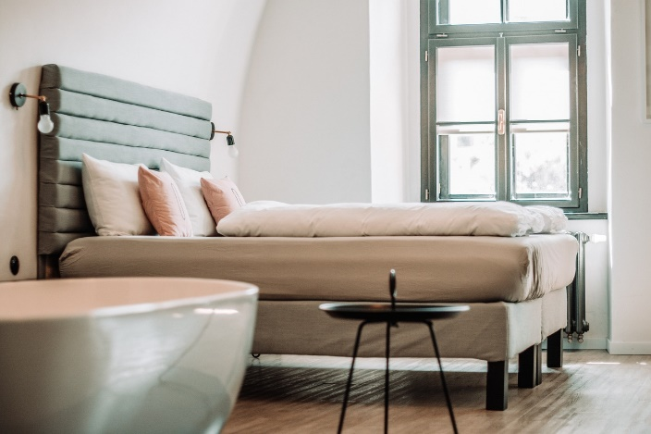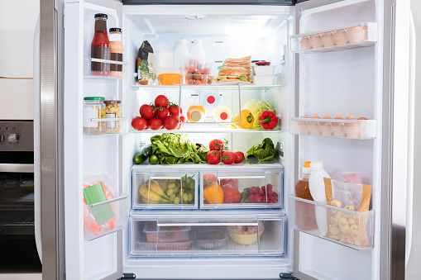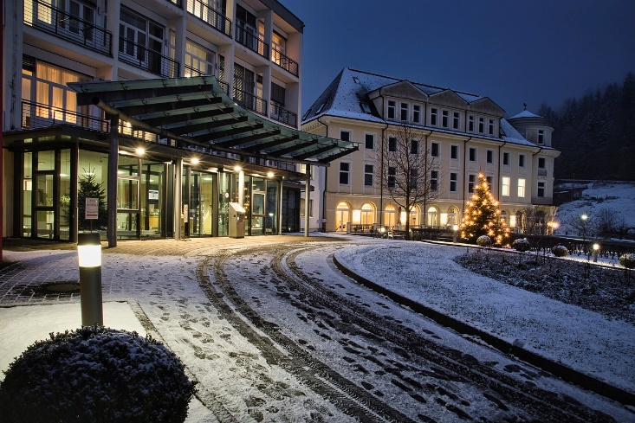That hotel is called Thanh Van, The hotel is in Buon Ma Thuot city, at 129 Nguyen Tat Thanh street. The location is good because it is near in the city center. I can go to the supermarket, school easily. My friend took me there by motorbike. I stayed in a single room because I travelled alone and I wanted to save money. The room rate is cheap. It's about 200,000 VND. There were a large TV and a twin bed. There are a lot of drinks and fast food. The hotel had laundry service and spa so I can relax after travelling a lot. I used wireless Internet service because I had a meeting online early that day and laundry service because I had a lot of dirty clothes. I did not request housekeeping service. I like the service and price most. I don't like the atmosphere, it's a little bit boring. I see a lot of good things so I will recommend to my friends.

# TOPIC 2: TALK ABOUT GOOD AND BAB DRIVING HABITS

Hello Mr. Dieu, my name is Tuan, today I will talk about good and bad driving habits First of

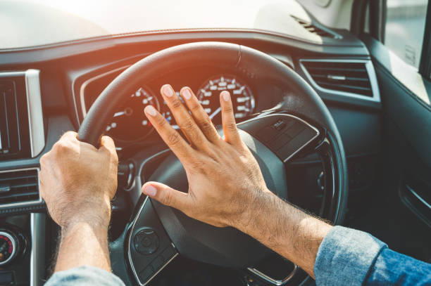all, The good driving habits are to pay attention, observe the speed limit, keep a safe

following distance. I usually keep a safe following distance and pay attention. The bad

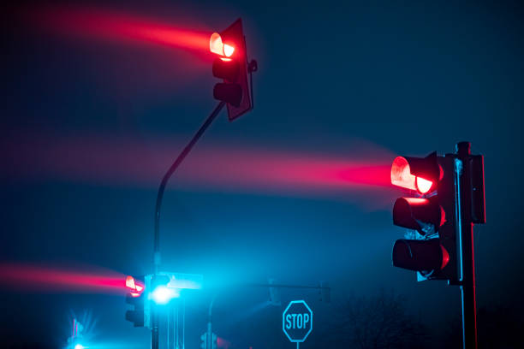driving habits are , talk on the phone, text while driving, speed, horn their horns, not signal

when turning, gesture at other drivers, flash lights at other drivers, not stop at red lights, pass

in a no-passing zone, weave through traffic. I think the most dangerous driving behavior is to

speed and not to stop at red lights. I'm ussually good driver, but sometimes I still make

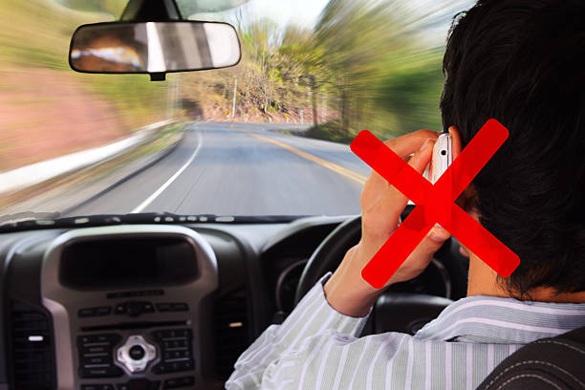mistakes. For example, I speeded while driving and I was punished. Finally, I hope everyone

will have good driving habits and avoid bad driving habits. Thanks for listening!

# TOPIC 3: TALK ABOUT HOW YOU TAKE CARE OF YOU APPEARANCE

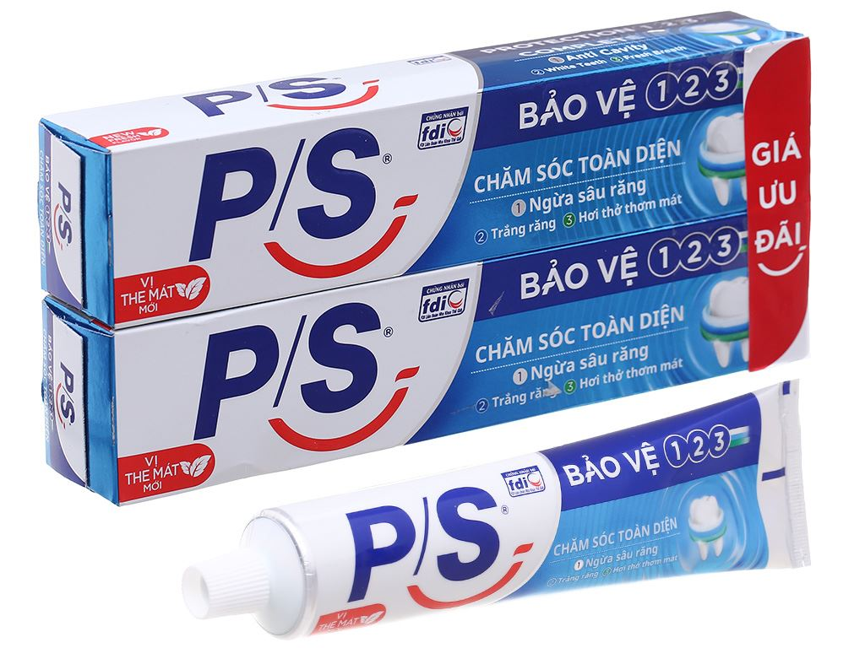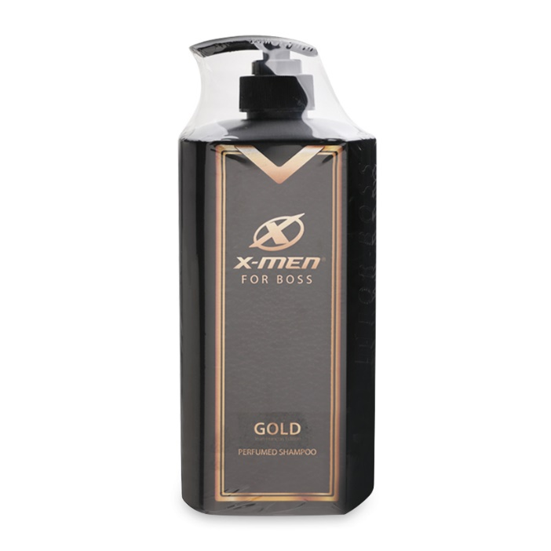 Hello Mr. Dieu, my name is Tuan, today I will talk about how to take care of my appearance. Appearance is also very importante to me. Appearance is also very importante to me. I usually brush my teeth twice a day and shower at least once a day. The personal care products I use are nivea cleanser , PS toothpaste, Xmen shampo. I don't go to spas often, but it very close to my house. In terms of plastic surgery, I think it's very popular these days it can give me more confidence. however I do not encourage. If I have a lot of money, I don't think I'll have plastic surgery, because I don't think it's needs for me.

# TOPIC 4: MY FAVORITE RESTAURANT

Hello Mr. Dieu, my name is Tuan, today I will talk about eating habit. I have never skipped breakfast because it is the most important meal of the day. I usually eat lots of fruits, vegetables and drink lots of water, eat Healthy foods like eggs, milk ... And I avoid high protein foods, RICH IN grease ... In order to maintain a healthy body, you should regularly exercise, eat a balanced diet and have a reasonable diet as possible. Thank you everyone for listening.